**PIZZA SALES SQL QUERIES**

**KPI’S**

1. **TOTAL REVENUE -**

SELECT sum(total_price) AS total_revenue FROM pizza_sales;



1. **AVERAGE ORDER VALUE-**

select sum(total_price) /count(distinct order_id) as avg_order_value from pizza_sales;



1. **TOTAL PIZZAS SALE-**

select sum(quantity) as pizza_sold from pizza_sales;



1. **TOTAL ORDERS-**

select count(distinct order_id) as total_orders from pizza_sales;



1. **AVERAGE PIZZAS PER ORDER-**

SELECT ROUND(SUM(quantity) * 1.0 / COUNT(DISTINCT order_id), 2) AS avg_pizzas_per_order FROM pizza_sales;



1. **DAILY TREND FOR TOTAL ORDERS-**

SELECT DAYNAME(order_date) AS day_name,

COUNT(DISTINCT order_id) AS total_orders

FROM

pizza_sales GROUP BY day_name ORDER BY day_name ;

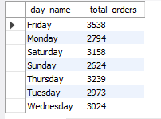

1. **MONTHY TREND FOR TOTAL ORDERS-**

SELECT monthname( order_date) AS month_name, COUNT(DISTINCT order_id) AS total_orders

FROM pizza_sales group by( month_name) order by total_orders desc ;

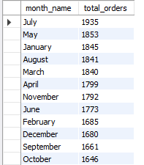

1. **PERCENTAGE OF SALES BY PIZZA CATEGORY-**

SELECT pizza_category, ROUND(SUM(total_price) * 100 / (SELECT SUM(total_price) FROM pizza_sales), 2) AS percentage_by_orders

FROM pizza_sales GROUP BY pizza_category;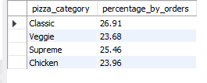

1. **PERCENTAGE OF PIZZA SALES BY SIZE-**

SELECT pizza_size, ROUND(SUM(total_price) * 100 / (SELECT SUM(total_price) FROM pizza_sales), 2) AS percentage_by_orders

FROM pizza_sales GROUP BY pizza_size order by percentage_by_orders desc ;

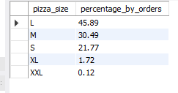

**10.TOTAL PIZZA SOLD BY PIZZA CATEGORY-**

SELECT pizza_category, SUM(quantity) AS total_revenue

FROM pizza_sales GROUP BY pizza_category order by total_revenue desc ;

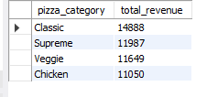

**11.TOP 5 BY REVENUE -**

SELECT pizza_name , SUM(total_price) AS total_revenue

FROM pizza_sales GROUP BY pizza_name order by total_revenue desc limit 5 ;

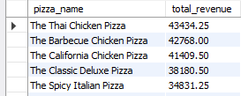

**12. BOTTOM 5 BY REVENUE-**

SELECT pizza_name , SUM(total_price) AS total_revenue

FROM pizza_sales GROUP BY pizza_name order by total_revenue asc limit 5 ;

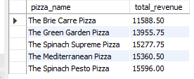

**13. TOP 5 BY QUANTITY SOLD-**

SELECT pizza_name , SUM(quantity) AS total_quantity_sold

FROM pizza_sales GROUP BY pizza_name order by total_quantity_sold desc limit 5 ;

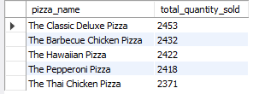

**14. BOTTOM 5 BY QUANTITY SOLD-**

SELECT pizza_name , SUM(quantity) AS total_quantity_sold

FROM pizza_sales GROUP BY pizza_name order by total_quantity_sold asc limit 5 ;

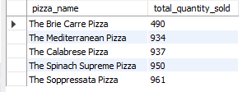

**15. TOP 5 PIZZA BY TOTAL ORDERS-**

SELECT pizza_name , count(distinct order_id) AS total_orders

FROM pizza_sales GROUP BY pizza_name order by total_orders desc limit 5;

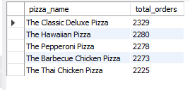

**16. BOTTOM 5 PIZZA BY TOTAL ORDERS-**

SELECT pizza_name , count(distinct order_id) AS total_orders

FROM pizza_sales GROUP BY pizza_name order by total_orders asc limit 5;

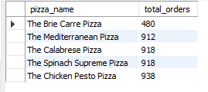

**THANK YOU -**